**HOW WORD PICKER WORKS**

Word Picker is a java web application developed in eclipse. To run the web application, Add the your postgres super user details to pickwords.java file. This allows the web application to create its own database and tables. The web application was tested on a jetty server running in eclipse and open in a browser.

**On launch, home page shows**

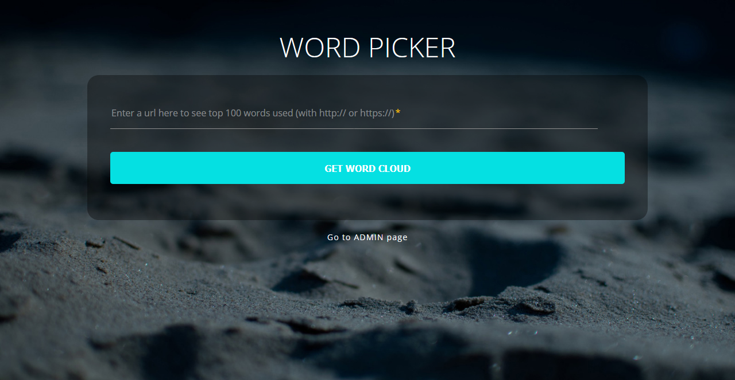

**Paste in Url (with protocol)**

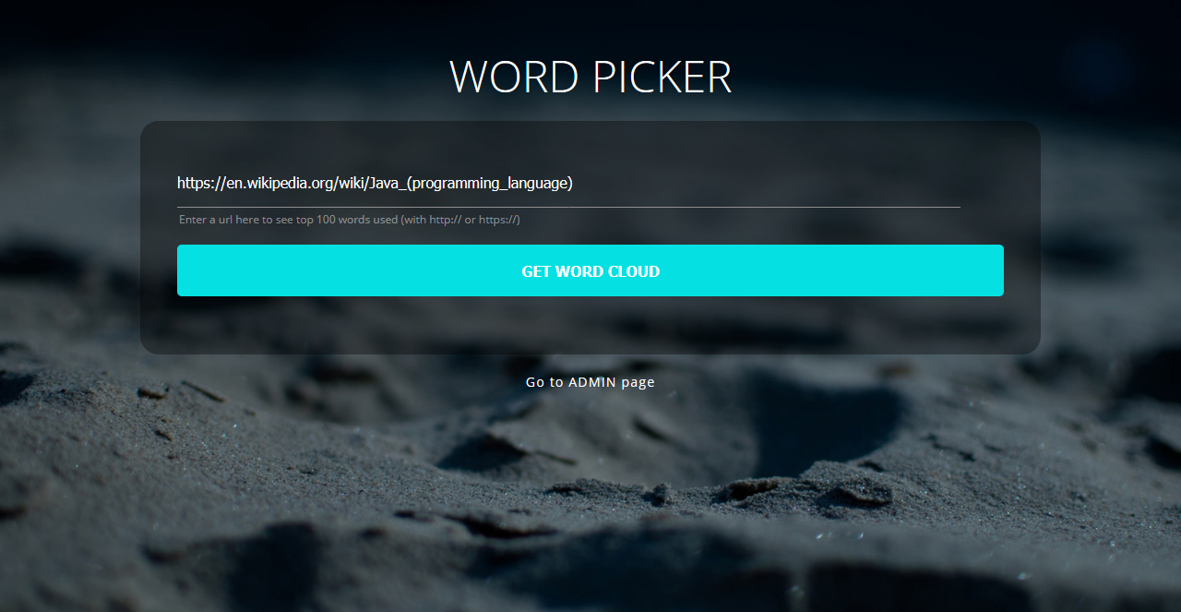

**Click “get word cloud” and wait**

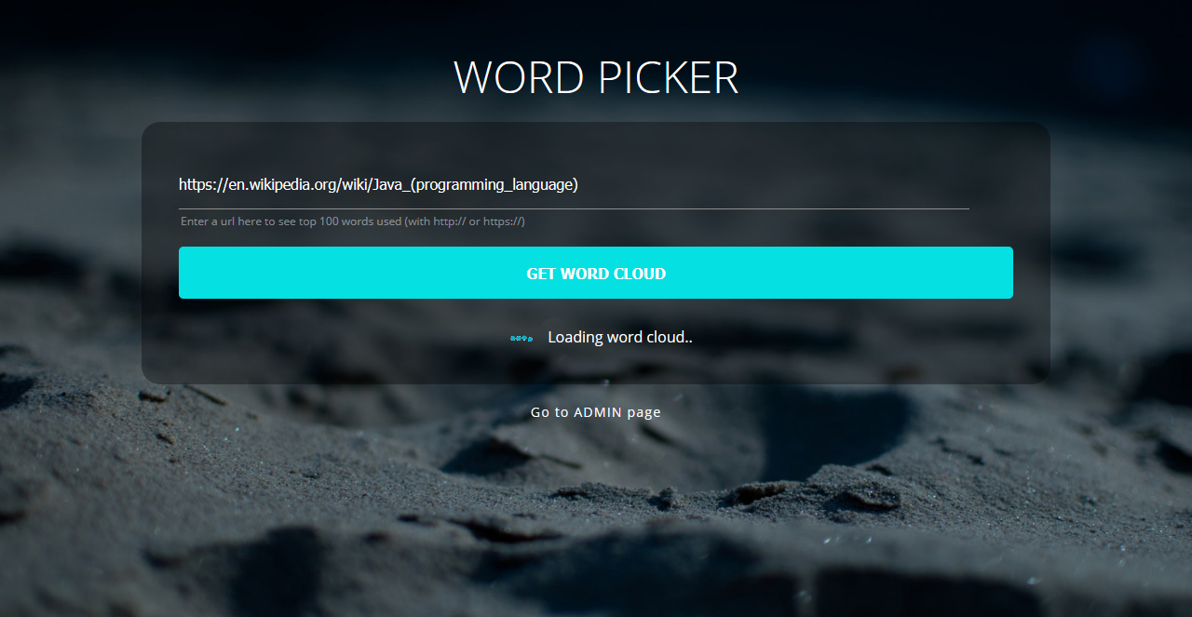

**Results will show top 100 words from the one with highest frequency having biggest**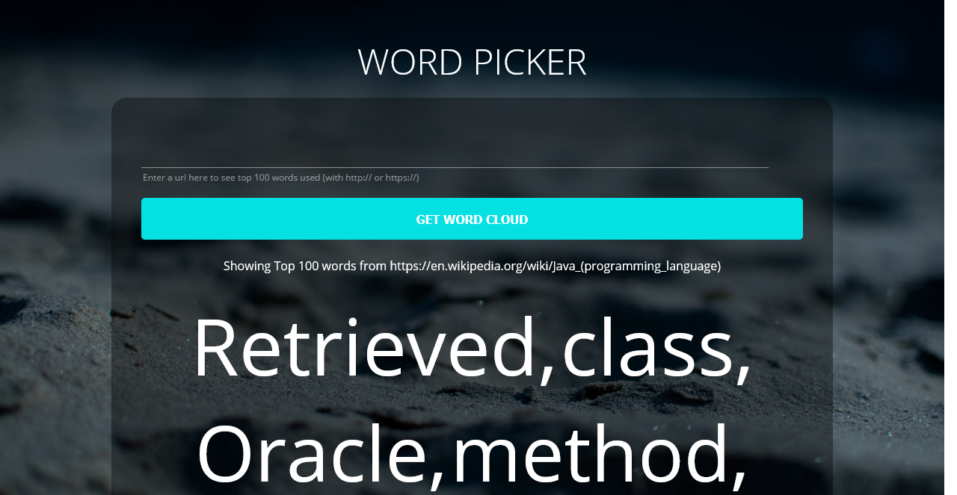

**To smallest having the lowest frequency**

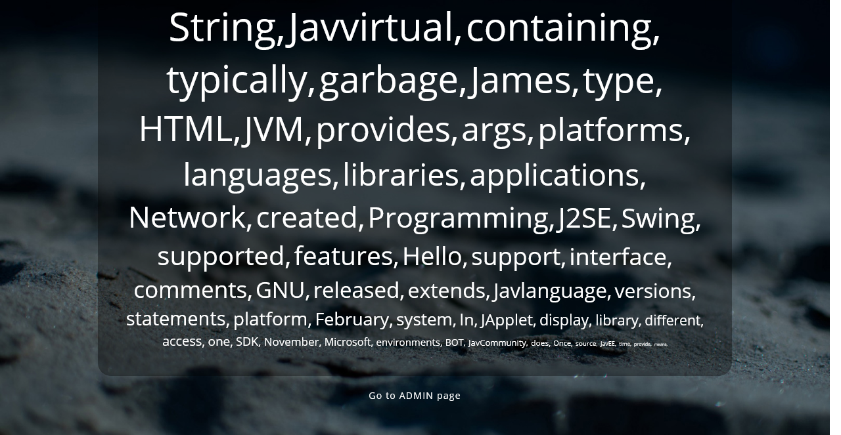

**Click “Go to admin” at bottom of home page to go to admin page**

